May 25-29  Under the Sea | MONDAY  ALC CLOSED | TUESDAY | WEDNESDAY | THURSDAY  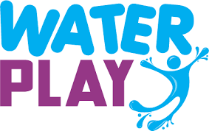 | FRIDAY  Movie Day!  The Little Mermaid
June 1-5  Science Fun | MONDAY | TUESDAY | WEDNESDAY | THURSDAY | FRIDAY  Movie Day!  Wall E
June 8-12  Picnic Fun | MONDAY | TUESDAY  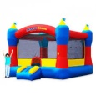 | WEDNESDAY | THURSDAY | FRIDAY  Hammond Park  Picnic  Ice Cream!!!
June 15-19  Sports Time Fun | MONDAY  PLAYBALL | TUESDAY | WEDNESDAY | THURSDAY | FRIDAY  Movie Day!  Game Plan
June 22-26  Down on the Farm | MONDAY | TUESDAY  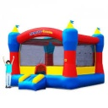 | WEDNESDAY | THURSDAY | FRIDAY  Movie Day!  Zootopia
June 29-Jul 3  Celebrating America | MONDAY | TUESDAY | WEDNESDAY | THURSDAY  4TH OF JULY PARADE | FRIDAY  ALC CLOSED
Jul 6-Jul 10  Healthy Cooking | MONDAY | TUESDAY | WEDNESDAY | THURSDAY | FRIDAY  Cooking Project  “Camp Makes Lunch”
July 13-17  Lights! Camera! Action! | MONDAY | TUESDAY | WEDNESDAY | THURSDAY | FRIDAY  Movie Day!  Cars 3
July 20-24  Super Hero | MONDAY  PLAYBALL | TUESDAY | WEDNESDAY | THURSDAY | FRIDAY  Movie Day!  Incredibles 2
July 27-31  Magic/ Fairy Tales | MONDAY | TUESDAY | WEDNESDAY | THURSDAY | FRIDAY  Movie Day!  Brave

