May 31st-June 3rd  Space Fun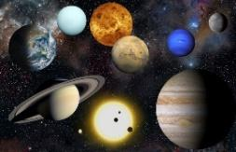 | MONDAY  ALC CLOSED | TUESDAY  Campers will create a Rocket Ship  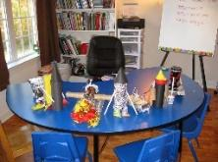 | WEDNESDAY  Playball  Campers will create a galaxy in a jar  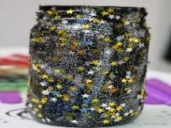 | THURSDAY  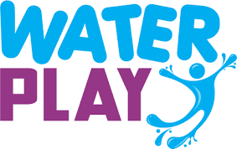  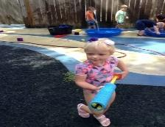 | FRIDAY  Campers will create a solar system mobile  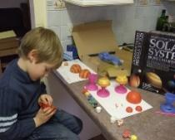
June 6th-10th  Science Fun  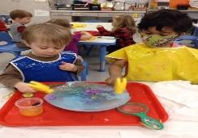 | MONDAY  Campers will create Play Dough  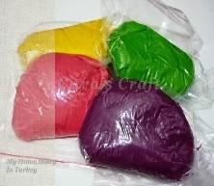 | TUESDAY  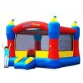 | WEDNESDAY  In-House Field Trip  The Science Wiz  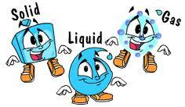 | THURSDAY  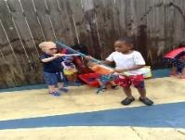 | FRIDAY  Campers will bring in their bikes or scooters from home.  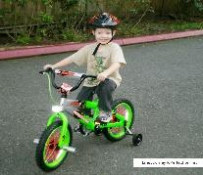
June 13th- 17th  Sports Time Fun  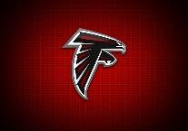 | MONDAY  Wear your favorite team shirt/attire | TUESDAY  Outdoor Bowling | WEDNESDAY  Playball  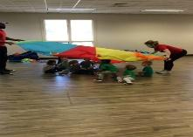 | THURSDAY  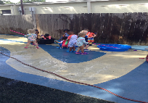 | FRIDAY  ALC Kickball Game  Staff and Campers  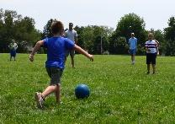
June 20th-24th  Picnic Fun  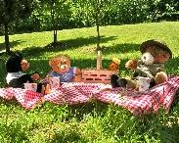 | MONDAY  In-House Field Trip  The Children’s Museum of Atlanta | TUESDAY  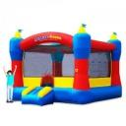 | WEDNESDAY  Campers will bring in their bikes or scooters from home  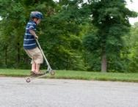 | THURSDAY  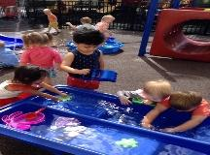 | FRIDAY  Campers will have a picnic @ Hammond Park  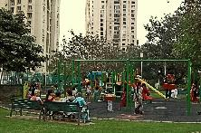
June 27th-July 1st  Celebrating America | MONDAY  Create Independence Day crafts | TUESDAY  Campers will create a kite  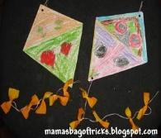 | WEDNESDAY  Playball  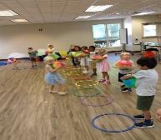 | THURSDAY  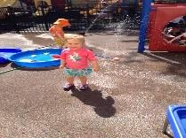 | FRIDAY  4th of July Parade  (Campers bring in their bikes from home.)  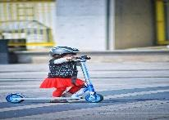
July 5th-8th  Healthy Cooking | MONDAY  ALC CLOSED | TUESDAY | WEDNESDAY  Create Healthy Snack  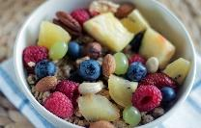 | THURSDAY  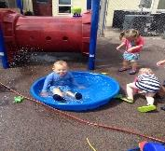 | FRIDAY  Cooking Project  “Camp Makes Their Lunch”  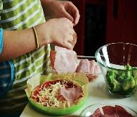
July 11th-15th  Down on the farm  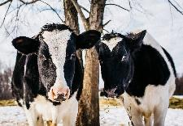 | MONDAY  Bring in your favorite stuffed animal  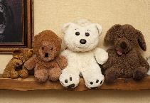 | TUESDAY  Campers will create farm animals  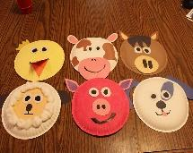 | WEDNESDAY  Playball  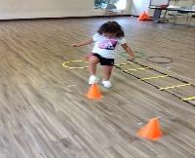 | THURSDAY  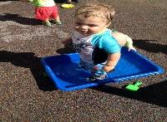 | FRIDAY  In- House Field Trip Crickets Mobile Petting Zoo  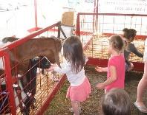
July 18th-22nd  Lights! Camera! Action! | MONDAY  Campers will prepare for the Talent Show | TUESDAY | WEDNESDAY  Campers will bring in their bikes or scooter from home  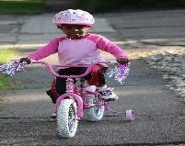 | THURSDAY  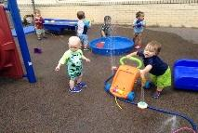 | FRIDAY  Talent Show  PSII-Camp (perform)
July 25th- 29th  Superhero  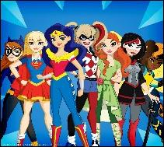 | MONDAY  Come dressed as your favorite Superhero | TUESDAY  Show & Tell  Bring your favorite Superhero toy  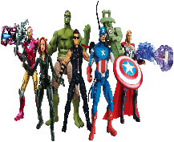 | WEDNESDAY  Playball  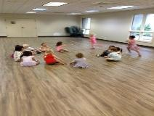 | THURSDAY  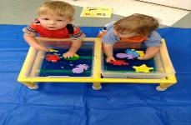 | FRIDAY  Campers will bring in their bikes or scooters from home.  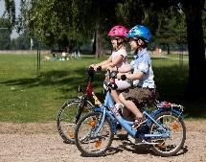
August 1st-5th  Under the Sea  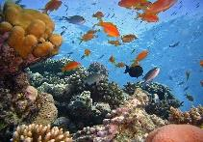 | MONDAY  Campers will create a jellyfish  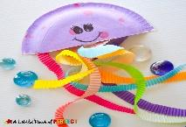 | TUESDAY | WEDNESDAY  Campers will create an edible under the sea craft. | THURSDAY  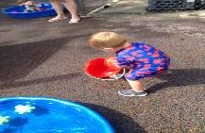 | FRIDAY  Campers will bring in their bikes or scooters from home  